Generalities

Every competitor is required to agree with the terms and rules of the League by signing the document attached to the registration form to any League championship. By doing so they acknowledge that they take part in the competition at their own risks, that they have subscribed to a personal insurance, that they accept that their name be mentioned when official results are published and their image be used on photographs and video clips made public in an aim to promote sport throwing.

Admission is for 16-year-olds and above. Throwers aged 16 to 18 must be accompanied by a parent or any authorized adult. Each competitor will be assigned an entry number and nominative score sheets.

Measurement instruments and weighing scales will be available for members of the League bureau and anyone in charge of approving the blades.
The rules shall be visible and available to all on the premises of the championship.
A first-aid kit shall be at the disposal of all competitors and be located in proximity with the throwing lanes.
In case of disabilities wanting specific adaptations, the tournament management team shall put in place all needed requirements so as to facilitate the events.

Behaviour, posture and outfit:

All competitors must present themselves at the competition in a state that is physically and psychologically compatible with taking sport events.
Characterized and repeated anti-sport behaviour from the part of a thrower will result in an eviction of the competition.
Physical violence will result in immediate exclusion from the competition.
It is strictly forbidden to smoke, including e-cigarettes, and to drink alcohol on the warm-up and competition throwing lanes. Any failure to abide by the rule will be followed by a warning. Any repeat will result in an exclusion of the competition.

It is strictly forbidden to use doping products prior to or during the competition, in accordance with decree n° 2018-6 from 15 January 2015 published in Journal Officiel, available on the Agence Française de Lutte contre le Dopage website. All offenders will be excluded from the competition.

The throwers shall wear sport shoes or safety boots. They shall wear decent and sufficiently covering outfit.

Judges and claims

A general judge shall be designated by the organizers whose role shall be to make the final decision in case of claims during the competition.
To be eligible the claim must be made to the rangemaster before the blade is pulled out of the target. Likewise, the scorer must inform the thrower immediately in case of a fault.

A technical committee is put in place, consisting of the general judge and two assisting judges.
This committee's task is to ensure the events be played correctly and that every competitor abide by the rules of the League.

The decisions of the committee are definite and unappealable. An appeal can never settle a score for a knife or axe throw – such decisions belong to the rangemaster only, and if required, to the general judge at the moment of the claim.

Claims must be transmitted on a written document and must bear – the family name and first name of the claimant, their function, the registration number of the thrower involved, the date and time of the claim deposit, the reasons for the claim and the signature of the claimant.

Coaching

One coach only is allowed on the throwing lanes to guide the thrower if considered useful, and only with words and simple gestures.
The coach shall stand at least two metres behind the thrower and the scorer.
They are not allowed to get closer to the thrower, nor to touch the blades, nor to approach the targets.
They are not allowed to check the scores on the targets, nor to contest them.
They are not allowed to have any contact with the scorer, nor to try and influence their judgement.
In no case shall they disrupt the event.

The blades

When registering, before starting the championship and if possible on the eve of the first events, the thrower shall display their blades for inspection. Those will be marked in an easily readable and perfectly visible way (i.e. a light fluorescent sticker) for approval.
For your information it takes a rangemaster 90 minutes to check the gear of 60 people.
Prior to each event, and for every thrower, the rangemaster shall control the “approved” marks on the blades.

In the set of rules below the phrase “the point value shall be a zero” means that the blade scores no point and that the thrower is not allowed to throw it again.

a) the knives

The thrower must present themselves with three identical knives at the start of the event. If one knife has been broken beforehand during the championship, while warming-up or on a preceding event, the thrower shall show the broken knife to the rangemaster and will be allowed to throw with the two remaining ones. Should they hold in their possession a fourth knife, identical to the other three, they will be allowed to use it provided it bears the “approved” mark set prior to the start of the championship.
The knives must be hard-blade and with a total length ranging from 23 cm to 42 cm. They must be single-blade, with a single or a double edge.
The metal part should not exceed 6 cm in width and be at least 2cm.
The cutting edge and the opposite edge should not exceed 6 mm in thickness, on the first 5 cm from the point of the knife. The rest of the metal part (the rest of the blade) may be 8 mm thick at most.
Knives with stabilizer fins or flights are not permitted. Handles may be covered with leather, wood or synthetic fabric.
The minimum weight of a throwing knife is 200g, whatever the throwing technique (rotational throwing or no-spin) and the event type (precision, speed or long distance).
The knife must be thrown with the hand, with no additional use of any other tool. It may be held either by the handle or by the metal, except for the duel cup, for which it may be held by the handle only.
For the throw to be valid, the metal must stick in the target by the tip. Should the knife handle stick in the target, the throw would be scored as a zero.

b) Axes and tomahawks

The axe must consist of a metal head with an eye in which the handle is fitted. All-in-one forged axes are not authorized.
The bladed edge must be between 60 mm and 120 mm long. It mustn't be higher than the line of the eye by more than 7 cm.
The bladed edge must be one-piece and with no angle.
Only the bladed edge, i.e. the part measuring between 60 mm and 120 mm may be sharpened. The other metal parts of the axe may be neither sharpened nor thinned.
For safety reasons any secondary spiked head must be blunted.
The total length of the handle, from the top of the eye to the bottom of the grip may range between 29 cm and 55 cm.
The minimum weight of the axe, including the handle, must be 500 g in total.

The thrower must present themselves with three identical axes at the start of the event. If one axe has been broken beforehand during the championship, while warming-up or on a preceding event, the thrower shall show the broken axe to the rangemaster and will be allowed to throw with the two remaining ones. Should they hold in their possession a fourth axe, identical to the other three, they will be allowed to use it provided it was approved prior to the start of the championship.

The axe must be held by the handle for throwing.

When a blade, knife or axe, sticks, it will be left in its position of impact and only the visible part of the edge in the target will determine the score.
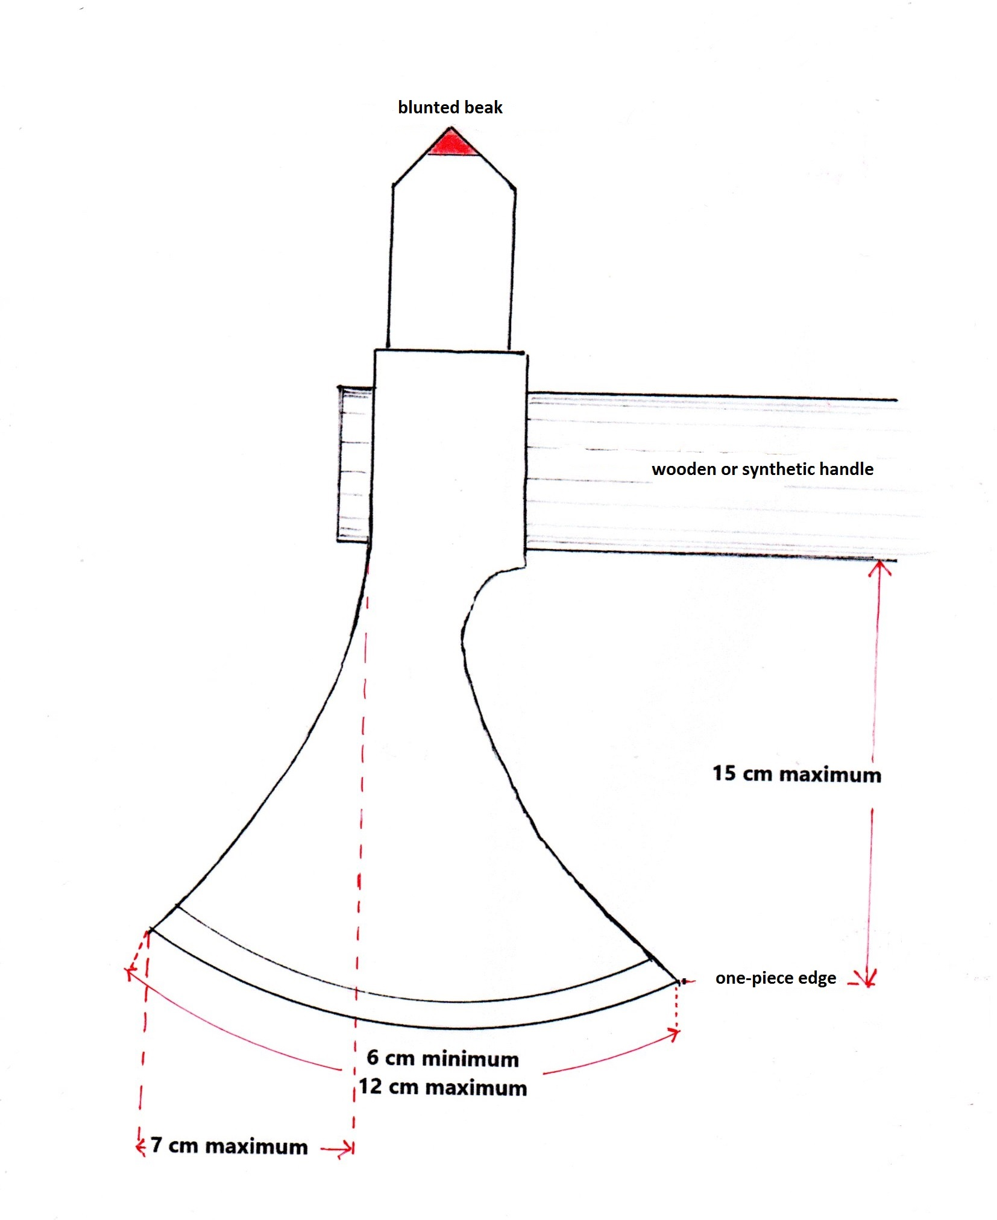
If the thrower touches the blade before the scorer has announced the score, the throw will be scored as a zero.
A thrower may ask the scorer to pull the blade out of a target if it obstructs the next throws. The thrower may pull the blade themselves once authorized by the scorer and resumes throwing as usual.

Throwing lanes

Championship throwing lanes should be left minimum 4 metres between one another both for events and warm-up.
Another option of secured throwing lanes is as follows:
The lanes are 2 metres away from one another. Half way are set hard or semi-hard fences, 3-metre-high and 4-metre-long, with a 5 x 5cm mesh size maximum.
In the case the events are taken on a wall where the targets are hung, a rangemaster will be in charge of giving the signal to start throwing and the signal to read the scores. Throws may be paused if necessary, i.e. when a blade has been lost or a competitor is lagging behind. The rangemaster will also be in charge of managing a two-blade competitor.

With a wall, all throwers are placed at the same distance and strictly follow the rangemaster's commands.

Should any competitor fail to comply, the rangemaster may send a warning and/or exclude the competitor. They are in charge of the safety of all throughout the event.

A 10-metre-wide safety zone behind the targets is mandatory, except if no passage is possible there due to the ground layout.
A minimum-4-metre-wide safety zone must be set behind the maximum throwing zone. Example: a throwing lane up to 7 metres means there should be a closed and secured zone up to 11 metres).
Access to those protected and secured zones is strictly restricted to throwers, scorers and members of the management team.

Targets

For ethical reasons, it is clearly stated that, including when not in competition, a throwing athlete should train only on targets made of wood or other material, dead trees or stumps. On no occasion should they throw blades at living vegetal, nor obviously at any animal or human being whatsoever.

The target, made of wood, is 50 cm in diametre.
The bullseye is a 10-cm-diametre circle.
The rings, which consist of 4 concentric circles, are all 5 centimetres wide.
A blade sticking in the bullseye is worth 5 points. The rings are worth respectively from the inside to the outside – 4, 3, 2 and 1 point(s).
If any part of the blade is seen touching the higher point ring, the corresponding point value is given. The tip of the knife must be in the target for the point to count.
The League recommends to materialise this dividing line with a
1-to-2-mm-thick line, thus limiting dispute.

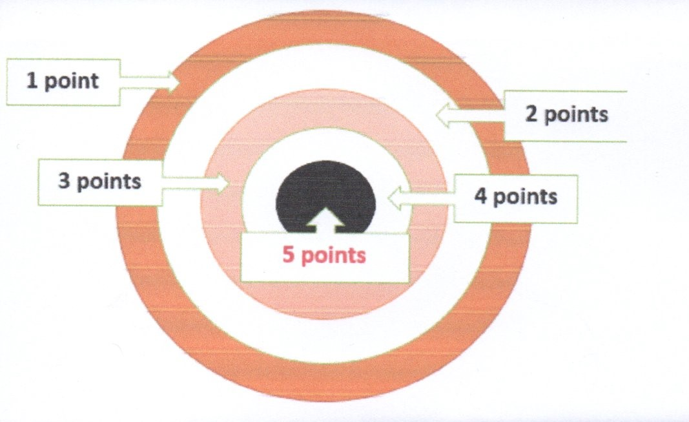
Target bullseye height is comprised between 1.25m and 1.60m from ground level.
The League recommends that the targets should be hung in a V-pattern, from left to right at 1.60m, 1.30m and 1.60m, by inter-national standards.

For long distance throws, the target must be maximum 1 metre wide. The bullseye, a 10-cm-diametre circle, should be considered a point of reference only.

Lanes

On championships there will be throwing lanes for warm-up and throwing lanes for competition. Warm-up lanes will be distinct from competition lanes.
The standard is to provide one 3-target throwing lane for a maximum of 7 to 10 competitors.
Competitors will enjoy seats and shades while waiting prior to and in between events.

When away from warm-up and competition zones, all blades shall be carried in locked-up containers.

Events

Generalities

For precision throws, throwers must have at least their foot that is closer to the target completely within the one-meter-wide determined zone, i.e. for a 3-metre-throw, the thrower must set their closer-to-the-target foot fully within the 3-4-metre zone. For a 4-metre throw, they must set their foot fully within the 4-5-metre zone and so on.

Whatever the distance, throwers are not allowed to cross the foul line before the knife or the axe has stuck. So for a 3-metre throw, if the thrower crosses the 3-metre foul line before the knife or the axe has stuck, the points will be scored as zero and the throw can't be tried again.
Should the thrower repeat the foul, their whole event will be invalidated. In no case will they be allowed to try again throughout the whole championship.
If the thrower wishes to do test throws before starting the round, they will be allowed to proceed, provided the test throws are limited to 3, and the rangemaster has been notified.
A throw may be validated before the end of the round if the blade seems likely to fall off the target, provided oral or gesture requirement is submitted to the scorekeeper by the thrower. Should the blade fall off the target before validation by the scorekeeper, the throw will be scored as a zero.
A thrower is not allowed to change their blades while an event is in process. If one of them breaks or is damaged, they may however use a spare blade provided it is identical to the discarded one and was approved beforehand. If no replacement is possible, the thrower will continue the event with two blades only.
At the end of a round, throwers walk up to the targets with their scorers to read the scores in concert. They are not authorized to touch the blades before the scorer has announced and marked the scores.
Both the thrower and the scorer validate the total score of the event immediately after the last throw by signing the score sheet. The scorer only is in charge of bringing the score sheet to the scoring office. The thrower cannot access their score sheet pending registration.
The knife may be held either by the metal or by the handle.
The events can be carried out with various throwing techniques, such as rotational throwing, half spin or no-spin.

The events that bear the ''no spin'' specific mention will be carried out using that throwing technique only.

The axe may be thrown with the metal head either forward or backward. It is therefore allowed to stick into the target with the handle upward or downward, whatever the throwing distance.
By the League standards for precision events, in case of a tie between two or more competitors for the top three rankings, the winner will be determined according to the highest number of 5-scores, then 4-scores, to avoid organizing play-offs. However, in case of perfect equality in the number of fives, fours, etc, a play-off is organized, consisting of a three-throw round. The play-off will continue until there is a winner.
All events are mixed-sex, but there are separate rankings for men and women, except for the knife- and axe- silhouette, speed throw, the duel cup and other possible duel events.
For a women's ranking to be possible, five competitors minimum are required.

a) precision events

- knife throws

Precision distances

3 metres: the competitor must throw 7 times 3 knives, with a total of 21 throws.
For each round, the first knife must be thrown at the target on the left, the second knife at the target in the middle and the third knife at the target on the right. If a knife sticks in the wrong target, the point value shall be a zero.
Total points possible are 105.

5 metres: the rules are the same as for the 3-metre event. The thrower must have at least their more forward foot within the 5-to-6-metre zone.

7 metres: the rules are the same as for the 3-metre and 5-metre events. The thrower must have at least their more forward foot within the 7-to-8-metre zone.

9 metres: 7 rows of 3 knife throws (i.e. 21 throws) may be added from that distance. The same rules apply as already mentioned.
The competitor must have at least their more forward foot within the 9-to-10-metre zone.

Walk Back
The competitor must throw 3 knives from a distance of 3 metres, then 3 knives from 4 metres, 3 knives from 5 metres, 3 knives from 6 metres and 3 knives from 7 metres. The row must be completed 4 times, for a total of 60 throws.
The first knife must stick in the left-hand-side target, the second one in the middle one and the third one in the right-hand-side target. A knife sticking in the wrong target will be scored as a zero.

EXCEPTION: for this event, the thrower is allowed one test throw for each distance, should they opt for it, i.e. 5 test throws, which should be carried out prior to the start of the event and with the rangemaster's ascent.
Total points possible are 300.

XTREM

The thrower is allowed three test throws at whatever distance they like.
The competitor starts throwing from a distance of three metres from the target and up to 11 metres. From each line they throw three knives (left target – middle target – right target).
Provided at least one knife sticks from one given distance, the thrower may move back to the next line with their three knives. The game ends when no knife sticks from one given distance. The score sums up all successful throws.
BONUSES:
In addition to the scores of the blades, the thrower is allowed bonuses as follows:
3 points if the 3-metre distance is validated, plus 4 points if the 4-metre distance is validated, plus 5 points for the 5-metre distance, and so on, up to 11 points if the 11-metre distance is validated.
Total points possible are 198.

Silhouette

The ''Silhouette'' consists of a central shape and 15 10-cm-wide round targets at a distance of 10 cm from the central shape. The lowest target is set 30 cm from ground level, the highest is between 180 and 230 cm.
Following the numbers, the competitor throws their three knives at targets 1, 2, 3 and take them back for targets 4, 5, 6, for 15 throws to target 15.

A knife sticking in the right circle is worth 5 points, a knife sticking in a neutral zone is scored as a zero. Any knife sticking in the central shape gives a penalty of -10 points. A knife missing its specific target is scored as a zero.

Total points possible are 75.

- Axe throws

The three precision events

4 metres: The athlete must throw their 3 axes 7 times, i.e. there are 21 throws in all.
For each series, the first axe is thrown at the leftmost target, the second axe is thrown at the middle target and the third axe is thrown at the rightmost target. If an axe sticks into a wrong target, it will be scored as a zero.
Total points possible are 105.

5 metres: the same rules apply as for the 4-metre event. The thrower must keep at least their foot that is closer to the target within the 5-to-6-metre zone.

7 metres: the same rules apply as for the 4-metre and 5-metre events. The thrower must keep at least their foot that is closer to the target within the 7-to-8-metre zone.

Walk Back

The competitor must throw 3 axes from a 4-metre distance, then 3 axes from a 5-metre distance, 3 axes from a 6-metre distance, 3 axes from a 7-metre distance and 3 axes from a 8-metre distance. The series must be carried out 4 times, i.e. there are 60 throws in all.
The first axe must stick in the leftmost target, the second one in the middle target and the third one in the rightmost target. An axe failing to stick in the right target will be scored as a zero.
EXCEPTION: for this event, the thrower is allowed a test throw for each of the distance should they wish to do so, i.e. 5 test axe throws, provided the rangemaster has been informed prior to starting the event.

Total points possible are 300.

X Trem

The competitor is allowed 3 test throws, at whatever distances they choose.
The competitor starts throwing from a distance of 4 metres and keeps moving back 1 metre after each series of 3 throws, up to a distance of 12 metres. For each distance, there are 3 axe throws (one at the leftmost target, one at the middle target, one at the rightmost target). As long as at least one axe has scored one or more points, the thrower may move back to the next zone. If no point is scored on one zone, the game is over. The total score validates all the points counted in the previous zones.

BONUSES:
In addition to the scores of the axes, the thrower is attributed bonuses as follows:
4 points if the 4-metre distance is validated, plus 5 points for the 5-metre distance, and so on, up to 12 points if the 12-metre distance is validated.

Total points possible are 207.

Silhouette

The ''Silhouette'' consists of a central shape and 15 10-cm-wide round targets at a distance of 10 cm from the central shape. The lowest target is set 30 cm from ground level, the highest is between 180 and 230 cm.
Following the numbers, the competitor throws their three axes at targets 1, 2, 3 and take them back for targets 4, 5, 6, for 15 throws to target 15.

An axe sticking in the right circle is worth 5 points, the point value for an axe sticking in a neutral zone shall be a zero. Any axe sticking in the central shape gives a penalty of -10 points. For an axe missing its specific target the point value shall be a zero.
If the edge of the axe touches both the circle and the central shape, the minus-10-point penalty applies.

Total points possible are 75.

See below an example of a knife or axe “Silhouette”. The shape and arrangement of numbers may not be symmetrical.
According to the League standards, it is recommended that two chronological numbers be not en-suite, so that no blade obstructs the next throws.

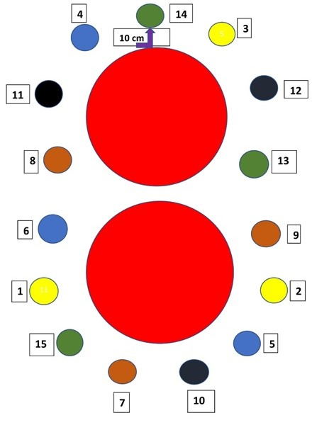

b) long-distance events

The target is one metre wide maximum and the bullseye is hung 1.50 m from ground level.
Throws start within the 7-to-8-metre zone, both for knives and axes. When a knife – or axe – throw is validated, the thrower moves back, within a range of 1 to 3 metres for knife throws – of 1 to 4 metres for axe throws. In other words, if a throw is validated from distance D, the next throw validated must be comprised between D + 1m and D + 3m for knife throws (D + 1m and D + 4m for axe throws).

The winner is the competitor having thrown the farthest.

c) speed throws

For knife speed throw events, competitors must use knives with a minimum weight of 200g. The target is a 50-cm-diametre circle with its centre hung 1.50m from ground level. The bullseye is only a point of reference.
The minimum distance for throwing is 3 metres.

– the knife speed throw
The competitor must throw as many knives as possible in 20-second time.
Competitors may lay their knives on a table at a height comprised between 70 cm and 90 cm. It may be positioned as convenient.
In accordance with the championship organization team, the starting time will either be announced by the master or correspond to the moment the first knife is thrown (exact time starts when the thrower stops touching the knife).

From the start, and throughout the 20 seconds, the competitor is allowed to hold as many knives as they want in their non-throwing hand. The throwing hand may not be in contact with the knives prior to start-off.
Only one knife may be thrown at a time.
If a throw is in process at the end of the 20 seconds, it may count since the thrower's hand was not in contact with the knife within the 20-second time.
Only the knives sticking in the target score. If a knife is supported by others but has not stuck, they will be scored as a zero.
Each valid knife scores 1 point.
The winner is the competitor getting the highest score.
In case of a tie for any of the top three ranks, a new event is organized, following the same rules and over 20 seconds. It may be repeated as many times as necessary to determine the ranks of every competitor.

– The Duel Cup, also called Quick Draw
50-cm-diametre target bullseye height is 1.50m from ground level.
The minimum distance for throwing is 3 metres.
The throwing hand must be positioned flat on the upper chest and touching the thrower’s collar bone.
The competitors' shoulders must be parallel to the throwing line.
The knife is in a sheath set on a belt. The metal is inside the sheath. For safety reasons, the knife may be thrown by the handle only.
The thrower may keep their hand on the sheath, but is not allowed to hold it above their belt (at navel level).

Should the guidelines above not be abode by, the point value shall be a zero.
Competitors draw and throw on the sound (and / or light) signal. The winner is the competitor whose knife sticks within the three-point ring of the target first or the competitor whose knife sticks within the three-point ring of the target at all within a 3-second time. They score 1 point.
If no knife has stuck, the round must be done again.
The winner of the series is the first competitor scoring 2 points.

